

Contents

1. Abstract 3

2. Scope of project 3

3. Background 3

4. Motivation and Problem 3

5. Solution of problem 4

5.1 Inefficiencies in current system 4

5.2 How we will address these issues 4

6. Block diagram 5

6.1 Software requirements 6

6.2 Hardware requirements 6

7. Values 6

8. Challenges 7

9. Advantages of the system 7

10. Disadvantages of the system 7

11. Gantt Chart 8

12. Conclusion 8

13. Future work 9

References 9

List of figures

**Figure 1 High-level diagram of the system** 5

**Figure 2 Gantt Chart** 8

# Abstract

This proposal is going to introduce an IoT (Internet of Things) based face recognition attendance system to resolve written presence of documents, address the problem of the fake involvement of the student, and update student attendance every day. This system helps the people by saving time by registering in android applications, which enables them to know the academic performance and attendance report anywhere.

# Scope of the project

In this project it includes the IoT hardware implementation technology can choose (using Arduino or Raspberry Pi) after research which technology is convenient to solve the problem. Moreover, implementation of connection with an android application to the database where the student can access their attendance report.

# Background

Student attendance is a crucial factor for success in a course for students. At some university student presence in a class is also used as one of the student's criteria for taking the exam (Islam et al., 2017). A conventional approach to record student's attendance is by asking every students name and go through with list and mark them on software. However, in some colleges, student's attendance is done by asking each student to sign on a list of presence that passes through all students at the beginning of the lectures. Therefore, in terms of time, this approach is inefficient and can ultimately lead to fraud, especially in a large class, where a student may sign on the attendance list for other students who are not in the class.

Many automated attendance systems were suggested based on face recognition, biometric recognition, barcode, QR code and mobile device for near-field communication (Sunaryono, Siswantoro, & Anggoro, 2019). However, in terms of processing time and precision, previous systems are inefficient.

# Motivation and Problem

Presence and academic success are also directly linked to educational institutions. Hence, an intelligence management skill must be needed in a place. Most schools or colleges still use paper-based attendance techniques to monitor attendance. Moreover, other educational institutions use the software-based presence for students, where they must click through and mark them one by one in a list. In some cases, when teachers forget to take course attendance, they need to change or mark them to save students ' participation in the database daily.

# Solution of the problem

The IoT based Face Recognition Attendance Management System aims at replacing the current attendance systems and thus automating almost the entire process. By using Computer Vision supported by IoT based cameras at the hardware level. By pictures will be taken by webcam, sent to a local server for analysis and the attendance of the entire class is stored in a database which is on the cloud, and which is accessible for professor and the students via an Android app.

## Inefficiencies in the current system

**Table 1 Comparison with the existing system**

|  |  |  |
| --- | --- | --- |
| RFID (radio frequency identification) | Biometric (Fingerprint or IRIS) System | Face recognition |
| Privacy concerns the use of RFID on products that can be easily tapped or blocked. | Software and appliance costs for fingerprints much more | Even after the picture is taken, the camera may not have covered the entire class |
|  | It is Time-consuming process, where students might have to wait in line for punch-in. |  |

## 5.2 How we will address these issues

* Build a low-level board device that is economical
* Easy to use and manage with utility programmes on the server
* Easy installation with Android apps
* Provide real-time device control
* Increase class coverage from required cameras from different viewpoints.

# Block diagram

Block diagram of the system is defining how the system will work in a real-life scenario.

Cloud /Database server

 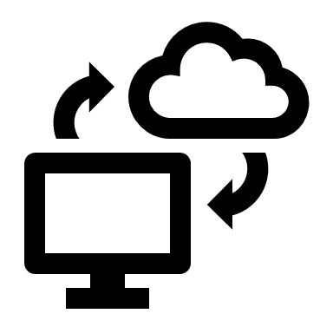

Database/ server to store data



Wi-fi network





Wi-Fi module

IoT Hardware

Smart phone

Power adapter

**Figure 1 High-level diagram of the system**

Figure 1 describes the flow of the system. The proposed system will work based on face recognition using the webcam. IoT hardware in figure 1 could be Arduino or raspberry pi for detecting the face and send data to the cloud.

Webcam can place in a classroom where it can capture student's face easily by covering the room corner, which is connected to the IoT hardware. IoT hardware which relates to power adapter which will process and send image using wi-fi network to the cloud server, where data (includes their personal information, course information) is stored and compare it.

Android application is also connected with the server using the internet. Using the android application professor and students get their information regarding their presence for each class and access it. However, if a student's face cannot capture by webcam, then by using android application professor can change student's attendance manually.

The system is trained with data which includes student's personal information and educational information with their image. Therefore, while taking an image by using webcam in a class, the system will able to compare the taken image by a camera with an existing image of student's and compare it to store their attendance of each course.

## 6.1 Software requirements

* Arduino IDE
* OpenCV
* Android Studio IDE
* phpMyAdmin database
* python

## 6.2 Hardware requirements

* Arduino Uno/Raspberry pi
* Breadboard
* Jumper wires
* Sensors
* Webcam
* Android smartphone

# Values

The proposed system increases the requirements of technology, in terms of business value, to make education institutes effective and sustainable. By using the android app professor will view and manually manage attendance if the device is unable to recognize the face of the student. Students have access to an android application in which they can view their attendance report of each class.

From an ethical point of view, the system will mark attendance based on time marks.

Security: For instance, students mark absent student's presence in a significant class in individual universities or institutes, which leads to fraud.

Reliability: Proposed system improves the performance and reduces the time required to take the student's presence.

The proposed system camera covers the entire corner of the classroom from the environmental perspective, recognizing the faces of the student and making it accurate.

# Challenges

* Cost: In terms of price, apply the system in a real-time world its expansive in the configuration.
* Required technical person to maintain the system.
* Wi-fi internet configuration must need.
* Information of student and faculty must be registered in the database.

# Advantages of the system

* A full network of self-contained pictures with a server
* Real-Time access to the database for teachers and students to point out irregularities (if a student is present but wasn't recognized) via Android App
* Separate teacher and student app to avoid giving students access to the teacher app
* Android App would function in both Manual (for editing by Teachers) and Automatic Mode.
* Facial Features are unique, and it wouldn't be possible to fake them in any way

# Disadvantages of the system

* Facial recognition different face corners may throw.
* High-cost installation and maintenance.
* Privacy : Privacy concerns are one of the significant challenges facing face recognition technology because face data that is being processed can be accessed by other third parties if the device is hacked or misused by the companies or organisations that collect biometrics of your face.
* Accuracy: From a different viewpoint of faces and emotions sometimes doesn't give the correct and accurate picture of the individual.

# Gantt Chart

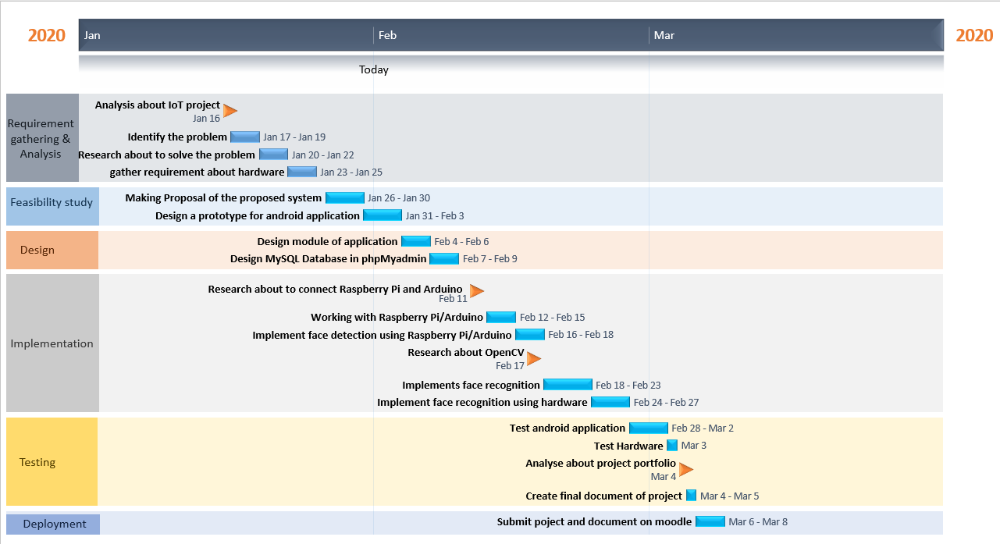

**Figure 2 Gantt Chart**

The Gantt chart separates project responsibilities and where we need to go through all the sub-project tasks involved. It can specify who will be responsible for each task as part of this project, how long each task will take (Michele, Mind Tools Content Team, Mind Tools Content Team, & Mind Tools Content Team).

The Gantt chart illustrates a project schedule. Figure 2 is defining the task that needs to complete in the given timeline. In this project, the task is defined in the blue rectangular symbol, and the milestone is set in the orange flag.

Each task defines the operation that needs to perform and to complete the project. However, milestones include high priority task, checkpoints and deliverables.

For this project plan, a milestone is, analyse the IoT project, research about Arduino/ raspberry pi and OpenCV these all are important to understand to complete the task.

# Conclusion

In conclusion, this proposal is mainly focused on IoT based intelligent attendance system which generates correct attendance and stores accurate data in the cloud. With automatic class attendance system, teachers can more accurately and quickly track student’s time in the classroom. It eliminates duplicate data entry and errors in time and attendance entries.

# Future work

Android application

* Professor task in the android app where they can change attendance manually.
* Professor can send email to absent students.

IoT hardware

* Video streaming in a classroom.

# References

Islam, M. M., Hasan, M. K., Billah, M. M., & Uddin, M. M. (2017). Development of smartphone-based student attendance system. *2017 IEEE Region 10 Humanitarian Technology Conference (R10-HTC)*. doi: 10.1109/r10-htc.2017.8288945

Michele, Mind Tools Content Team, Mind Tools Content Team, & Mind Tools Content Team. (n.d.). Gantt Charts: Planning and Scheduling Team Projects. Retrieved from https://www.mindtools.com/pages/article/newPPM_03.htm

Sunaryono, D., Siswantoro, J., & Anggoro, R. (2019). An android based course attendance system using face recognition. *Journal of King Saud University - Computer and Information Sciences*. doi: 10.1016/j.jksuci.2019.01.006